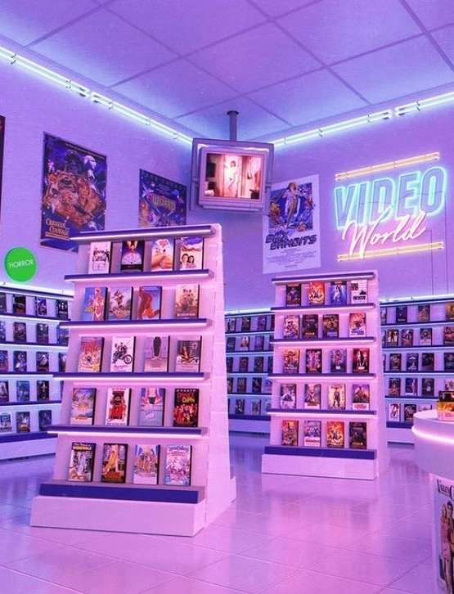
Deepika Maram – u1449099
Nikita Vijayrao Zatale – u1484250
Omkar Sai Munjuluri – u1482645
Supriya Mulpuru – u1494577
Group - 3
IS 6480
Data Warehousing Group Project -
Video World DVD Rentals
Table of Contents

- Executive Summary …………………………………………………… | 3
- About the Organization ………………………………………………... | 4
- Dimensional Model Requirements …………………………………..... | 5
- Dimensional Model ……………………………………………………. | 6
- Dimensional Tables ………………………………………………………… | 6
- Fact Table ……………………………………………………....................... | 7
- Data Warehouse Architecture ………………………………………..... | 8
5.1 Data Extraction ………………………………………………………………… | 9
5.2 Data Transformation …………………………………………………………… | 9
5.3 Data Loading …………………………………………………………………… | 10
- Dashboards & Analysis ………………………………………………... | 11
6.1 Executive Dashboards ………………………………………………………….. | 11
6.2 Employee Dashboards ………………………………………………………….. | 16
- Appendix ………………………………………………………………. | 18

- Executive Summary
This report outlines the design and implementation of a Data Warehouse (DW) for Video World, a leading DVD rental service. The primary business objectives of Video World are to optimize DVD inventory management and enhance customer satisfaction through personalized recommendations and targeted promotions. The data warehouse is intended to address these objectives by providing comprehensive insights into inventory levels, rental history, and customer preferences.
The project approach involved developing a data warehouse with dimensions including customer, date, store, film, category, and rental. This structured format enables efficient data organization, which supports detailed reporting, analysis, and visualization. Key visualizations derived from the data warehouse include dashboards for inventory analysis, rental history, customer insights, and recommendations and promotions. These dashboards, created using Power BI, will enable Video World to monitor and manage inventory effectively, understand rental trends, and tailor marketing strategies to individual customer preferences.
Data staging is performed within the data warehouse, ensuring that all relevant information is accurately processed and stored for analysis. By leveraging the data warehouse, Video World expects to achieve significant improvements in inventory management, reducing instances of stockouts and overstocking. Additionally, personalized recommendations and timely reminders for new arrivals and promotions are anticipated to boost customer satisfaction and retention. The data-driven insights provided by the warehouse will inform strategic decisions, driving operational efficiency and enhancing the overall customer experience.
In conclusion, the implementation of the data warehouse for Video World is a critical step toward achieving the company’s strategic goals. It provides a robust foundation for data analysis and visualization, enabling Video World to optimize its operations and deliver superior service to its customers.

- About the Organization
Video World is a premier DVD rental service, renowned for its extensive collection of movies and television shows. Established in 2005, Video World has grown to become a household name, offering a diverse range of titles across various genres to cater to the entertainment needs of a broad customer base. With a commitment to providing exceptional service, Video World has established a strong presence both online and through its network of physical rental locations.
The core mission of Video World is to deliver an unparalleled entertainment experience by offering an extensive and up-to-date selection of DVDs. The organization prides itself on its customer-centric approach, striving to understand and meet the unique preferences of each customer. By leveraging data and technology, Video World aims to provide personalized recommendations, ensuring that customers always have access to movies and shows that match their interests.
To support its mission, Video World has invested in developing a sophisticated data infrastructure. The implementation of a data warehouse is a pivotal initiative in this regard. The data warehouse stages data to ensure accurate processing and storage, enabling detailed analysis. Visualization reports and dashboards, developed using Power BI, provide actionable insights that help Video World maintain optimal inventory levels, preventing stockouts and overstocking. Additionally, these insights facilitate the analysis of rental patterns and customer preferences, allowing for more effective marketing and promotional strategies.
Overall, Video World is dedicated to enhancing its service offerings through continuous innovation and data-driven decision-making. The data warehouse project, complemented by Power BI visualizations, is a testament to this commitment, providing the organization with the tools it needs to stay ahead in a competitive market and deliver exceptional value to its customers.

- Dimensional Model Requirements
Business Process | Customer | Film | Store | Category | Amount | Country | Rating | Inventory | Rental | Date
Inventory Management
Inventory Levels by Category |  | X |  | X |  |  |  | X
Rental Duration Analysis |  | X |  | X |  |  |  | X |  | X
Rental Trends Geographically |  |  |  |  |  | X |  |  | X
Rental Amount by Category name |  | X |  | X | X |  |  |  | X
Replacement Cost vs Category Name |  | X |  | X
Customer Insights
Top Customers | X |  |  |  | X
Top Rented Films |  | X |  |  |  |  |  |  | X

Requirement Name | Short Description | Status
Inventory Management
Inventory Levels by Category
Rental Duration Analysis
Rental Trends Geographically
Rental Amount by Category name
Replacement Cost vs Category Name
Customer Insights
Top Customers
Top Rented Films

- Dimension Model

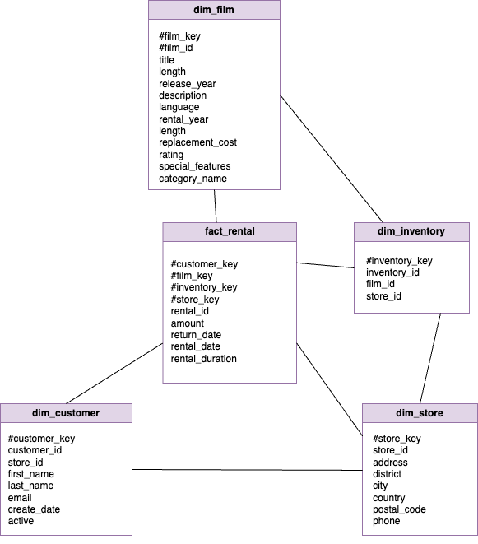

The dimensional model comprises 4 dimension tables and 1 fact table. The fact table contains metrics for analysis, while the dimension tables include attributes that serve as constraints for measuring the fact table's metrics.
  - Dimension Tables
dim_customer: The dim_customer table consists of customer data. It includes attributes such as customer_key, customer_id, store_id, first_name, last_name, email, create_date, and active. This table is essential for grouping and analyzing rental patterns based on customer attributes. For example, it can help determine which customers are most active or which customer segments generate the most rentals.
dim_film: The dim_film table consists of film data. It includes attributes such as film_key, film_id, title, description, release_year, language, rental_year, length, replacement_cost, rating, special_features, and category. This table helps in analyzing rental trends based on film attributes. For instance, it can reveal which genres or specific films are most popular, aiding in inventory management and marketing strategies.
dim_store: The dim_store table contains information about the stores. Attributes include store_key, store_id, address, district, city, country, postal_code, and phone. This table is useful for understanding rental distribution and performance across different locations. It allows for geographic analysis of rental patterns, helping to identify high-performing stores or areas needing improvement.
dim_inventory: The dim_inventory table contains inventory-related data, with attributes like inventory_key, inventory_id, film_id, and store_id. This table is critical for tracking the availability and status of DVDs across different stores, supporting effective inventory management.
  - Fact Table
fact_rental: The fact_rental table contains rental transaction data. It includes attributes such as rental_id, customer_key, film_key, inventory_key, store_key, rental_date, return_date, amount, and rental_duration. This table is the core of the data warehouse, capturing detailed rental transactions. It enables comprehensive analysis of rental patterns, customer behavior, and financial performance.

- Data Warehouse Architecture

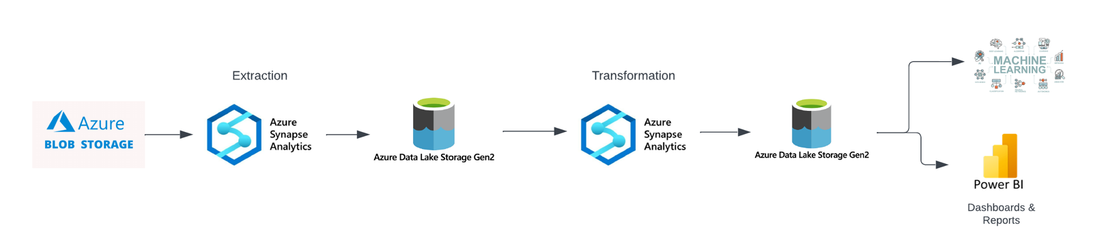
Our data warehouse architecture has been carefully crafted to meet the specific needs of "Video World." By utilizing Azure cloud services, we've established a powerful and scalable system to streamline and consolidate DVD rental data to facilitate comprehensive analysis and data-driven decision-making, which is vital for business growth.
The centralized data warehouse integrates data, which offers a holistic view of customer behavior, rental patterns, and film inventory. Azure cloud services underpin our architecture, ensuring efficient data processing and scalability. Optimized data pipelines are employed to extract, transform, and load data from source systems to the staging and presentation areas. These pipelines ensure timely data acquisition, cleansing, and integration. The staging area serves as an intermediary space where data is refined and validated before being moved to the presentation area.
The data extraction process begins with Azure Blob Storage, where raw data in CSV format is retrieved and stored securely. Azure Synapse Analytics orchestrates the movement of data from Azure Blob Storage to Azure Data Lake Storage Gen2, forming the bronze layer where each dataset is stored individually in its raw format. This setup maintains data integrity and prepares it for further processing. Transformation of data from the bronze to the silver layer is performed using Azure Synapse Analytics. This step involves data cleansing, table joins, and the removal of unnecessary columns to create denormalized and enriched datasets. The silver layer, housed in Azure Data Lake Storage Gen2, contains this refined data, ready for efficient access and analysis.
The final transformation and data loading into the data warehouse is managed by Azure Synapse Analytics. This stage integrates all dimensional and fact tables, adds necessary calculated columns, and prepares the data for analysis. Rental transactions are transformed and loaded into the fact table (fact_rental), which is integrated with the silver dimensional tables (customer, film, inventory, store). Calculations for rental duration and rental amount are also performed during this stage.
Power BI is utilized to create interactive dashboards and reports that visualize the data stored in the data warehouse. By leveraging the clean, structured, and enriched data, machine learning models can be developed to predict customer preferences, optimize inventory levels, and recommend personalized content to users, thereby enhancing customer satisfaction and operational efficiency.

Pipelines | Operation | Pipeline Name in Azure Data Factory
Pipeline 1 | Extraction | pl_extract_dvd_rentals_data_to_lakehouse
Pipeline 2 | Transform | pl_transform_bronze_customer_to_silver_dim_customer
Pipeline 3 | Transform | pl_transform_bronze_film_to_silver_dim_film
Pipeline 4 | Transform | pl_transform_bronze_inventory_to_silver_dim_invetory
Pipeline 5 | Transform | pl_transform_broze_store_to_silver_dim_store
Pipeline 6 | Load | pl_load_fact_rental_to_warehouse

5.1 Data Extraction
Firstly, we created a workspace in Power BI and connected it to Microsoft Fabric. After that, we created a lake house named LH_iS6480_Group3_DVD_stage_1. Along with the lake house, we also created a data warehouse to load the transformed data into it.
Pipeline 1: pl_extract_dvd_rentals_data_to_lakehouse
We fetched data from the website in CSV format into an Azure storage container. The pipeline is used to acquire data from a source called Azure Blob and make it a bronze layer. In the bronze layer, each table is stored individually.
5.2 Data Transformation
Pipeline 2: pl_transform_customer_to_silver_dim_customer
In this pipeline, we transformed the customer table data into Silver_Dim_Customer. We joined the customer table with the address, city, and country tables to get comprehensive customer details in one table. We also performed denormalization to create a star schema for dimensional modeling. Before loading the data into the warehouse, we removed junk columns such as country_id, city_id, address_id, and address2 from Dim_Customer. Finally, we added a warehouse key called customer_key to facilitate analysis and data retrieval, and then pushed the table to the warehouse.
Pipeline 3: pl_transform_film_to_silver_dim_film
In this process, we transformed the film table data into Silver_Dim_Film. We joined the film table with film_actor, film_category, actor, category, and language tables. To make it a dimensional table, we removed junk columns such as full_text, film_category_id, actor_id, category_id, and film_actor_id. At the end of the process, we included a warehouse key column named film_key and then pushed the table to the warehouse.
Pipeline 4: pl_transform_inventory_to_silver_dim_inventory
In this process, we transformed the inventory table data into Silver_Dim_Inventory. We removed the last_update column and introduced a warehouse key named inventory_key. Finally, we pushed the table to the warehouse for analysis.
Pipeline 5: pl_transform_store_to_silver_dim_store
In this process, we transformed the store table data into Silver_Dim_Store. We joined the store table with address, city, and country tables. We removed unnecessary columns such as address_id, city_id, country_id, and last_update. At the end of the process, we introduced a warehouse key named store_key and then pushed the table to the warehouse.
5.3 Data Loading
Pipeline 6: pl_load_fact_rental_to_warehouse
In this process, we transformed the rental table into the dim_fact_rental table. We joined the rental table with Silver_Dim_Customer, Silver_Dim_Inventory, Silver_Dim_Store, Silver_Dim_Film, and payment tables. We chose the rental table as the fact table because our business objective is to maintain inventory with proper stock levels and provide customer recommendations based on their rental history. We added a column for rental duration, calculated from the rental date and return date columns. Additionally, we added a column for the amount, sourced from the payment table. We removed the last_update column. In the fact_rental table, we did not include any warehouse keys, as all warehouse keys from the dimension tables serve as primary keys for this table. Finally, we loaded the table into the warehouse.

This ETL process ensures accurate data extraction, transformation, and loading to support the business objectives of effective inventory management and personalized customer recommendations.

- Dashboards & Analysis
6.1 Executive Dashboard
The executive dashboards consist of all those reports related to inventory management and stock analysis which helps the executives monitor the availability of DVDs to prevent stockouts and overstocking.

Inventory Levels by Category name:
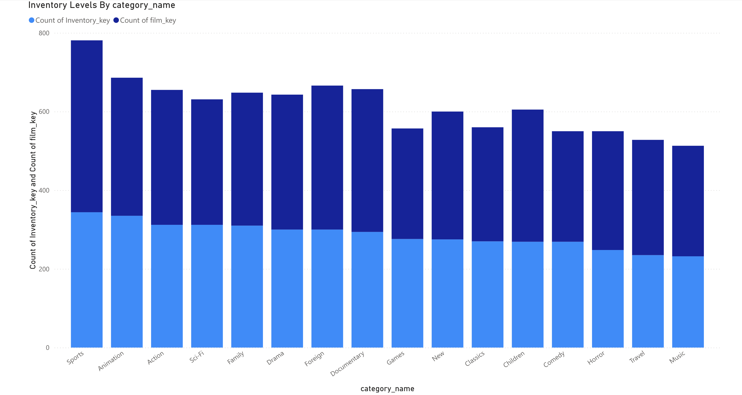
This stacked bar chart, "Inventory Levels by Category," gives a summary of the various inventory levels in different categories of movies. It compares the number of inventory keys against the number of film keys in each category, which directly indicates the amount of availability and variation of movie titles in stock. Each bar is a category, with the count of inventory keys in blue and that of film keys in a darker blue. In particular, at the top is Sport, very high in terms of inventory, thus holding a large stock and a number of titles to boot. Other categories, such as Animation, Action, and Sci-Fi, are also high in terms of their inventory levels, which indicates that these genres are well-stocked. On the other hand, the Travel, Music, and Horror categories have lower inventory levels, hence there is scope for improving the inventory. This, therefore, helps in pinpointing both high-level inventory categories and those that may require additional stocking, hence making inventory management better and offering a balanced set of movies to the customers.

Rental duration by Category name:
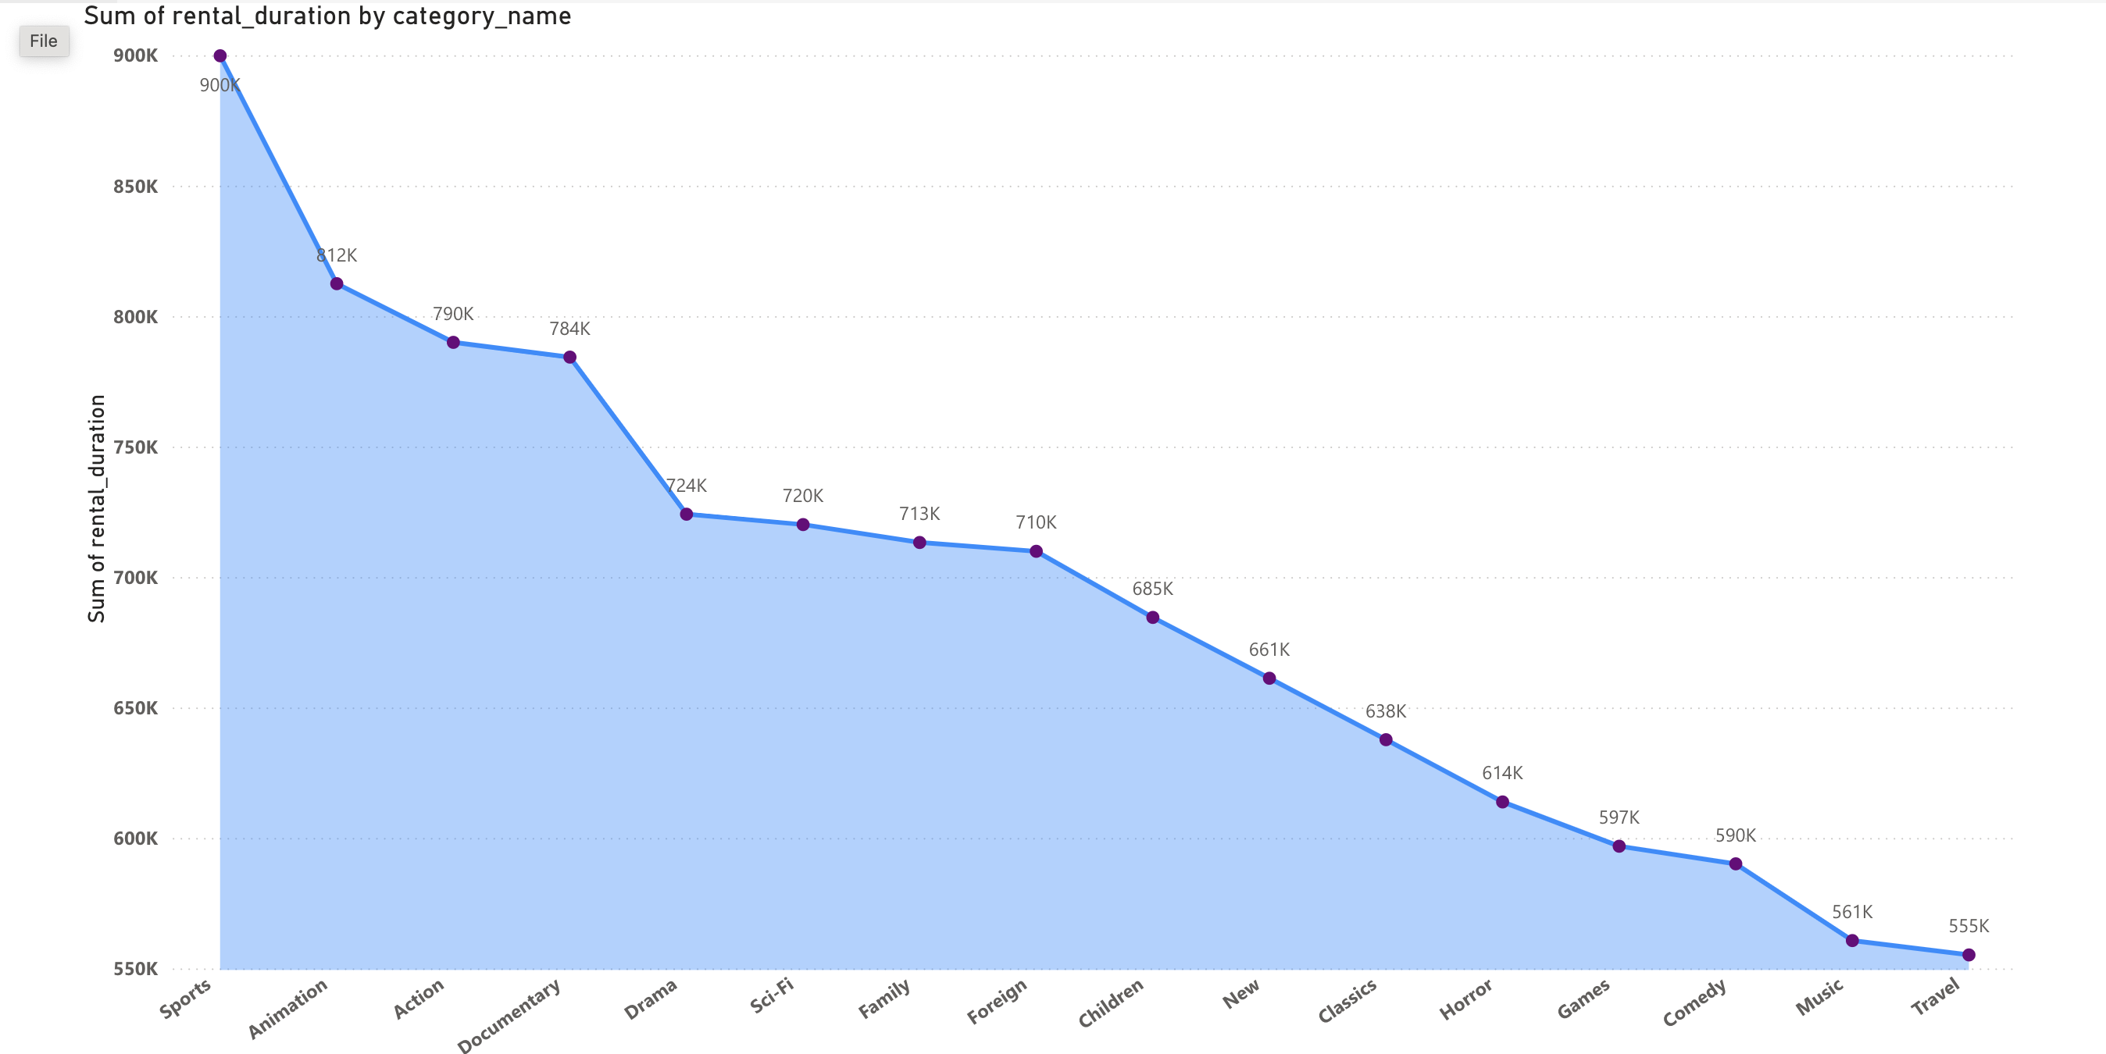
This area chart is used to "Sum of Rental Duration by Category." It graphically represents the sum of rental duration for various categories of films. It helps in customer preferences and renting behavior. The horizontal axis shows the different categories of movies in decreasing order according to their duration of hire, while the vertical axis indicates the sum of rental duration in thousands. According to the graph, the longest time the customers spent renting was in the Sports category at 900K, followed by Animation and Action with 812K and 790K respectively. Sci-Fi, Family, Foreign, and Children will be the middle tier of rental time categories ranging from 710K and 685K respectively. Games, Comedy, Music, and Travel are in the lower end with rental times of 597K to 555K. It assists in inventory management by identifying high demand categories, informs marketing strategies about popular categories, and creates a feeling of satisfaction with customers due to personalized recommendations against rental patterns.

Count of Rental_id by Country:
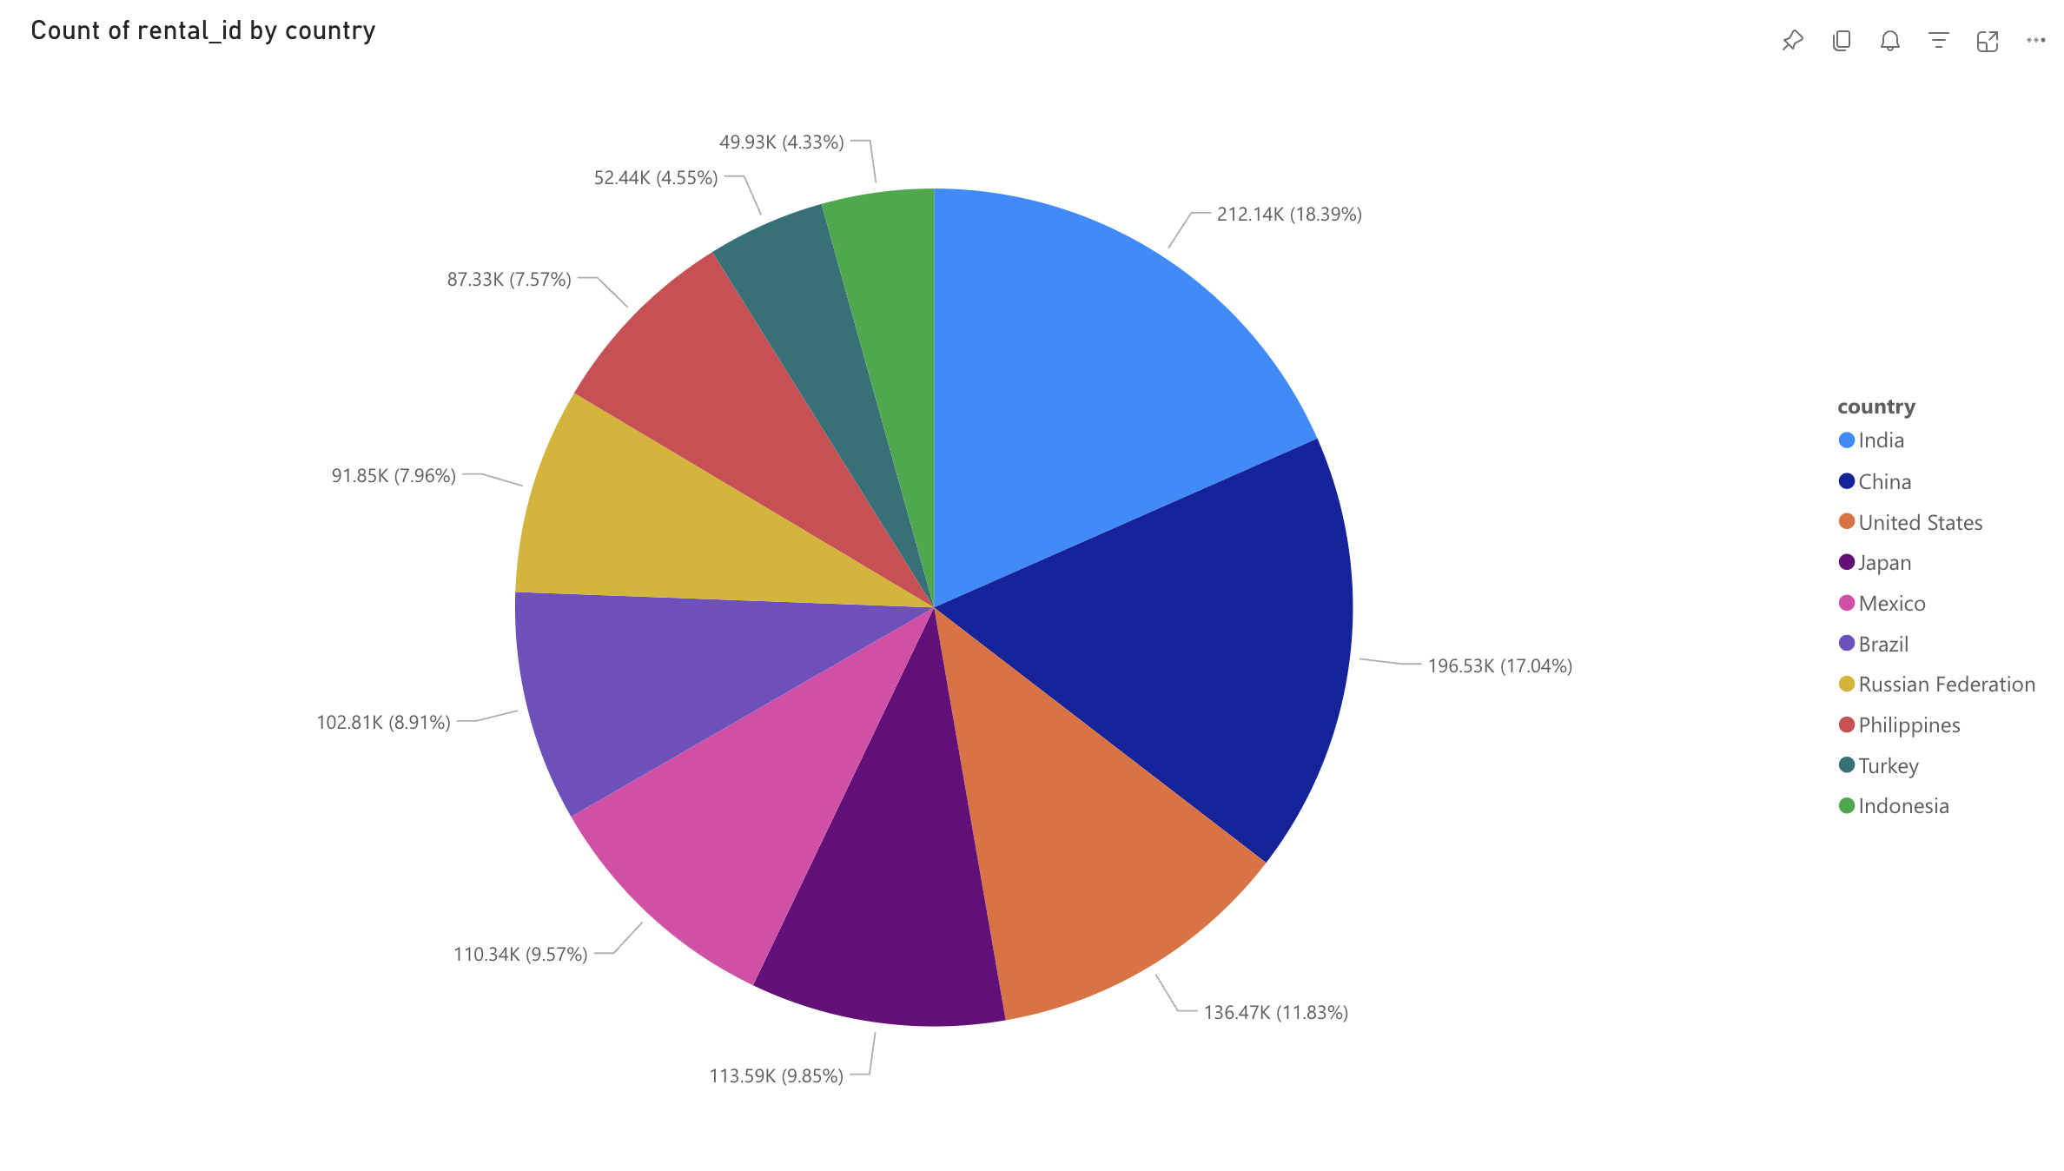
This pie chart, "Count of Rental ID by Country," expresses the proportion of DVD rentals across various countries, showing regional trends of rentals and market penetration. India has the highest count of rentals at 212.14K, representing 18.39 percent of the total rentals. Not far is China, with 196.53K rentals, representing 17.04%. The United States is also key in terms of providing 136.47K rentals, or 11.83% of the total. Other important countries are Japan, with 113.59K rentals (9.85%), Mexico with 110.34K rentals (9.57%), Brazil with 102.81K rentals (8.91%), and the Russian Federation with 91.85K rentals (7.96%). Others include the Philippines, Turkey, and Indonesia, with 87.33K, 52.44K, and 49.93K rentals, respectively. This clearly shows where DVD rentals are most leased out, therefore giving a clear hint on regional marketing and inventory strategies.

Rental amount by Category name:
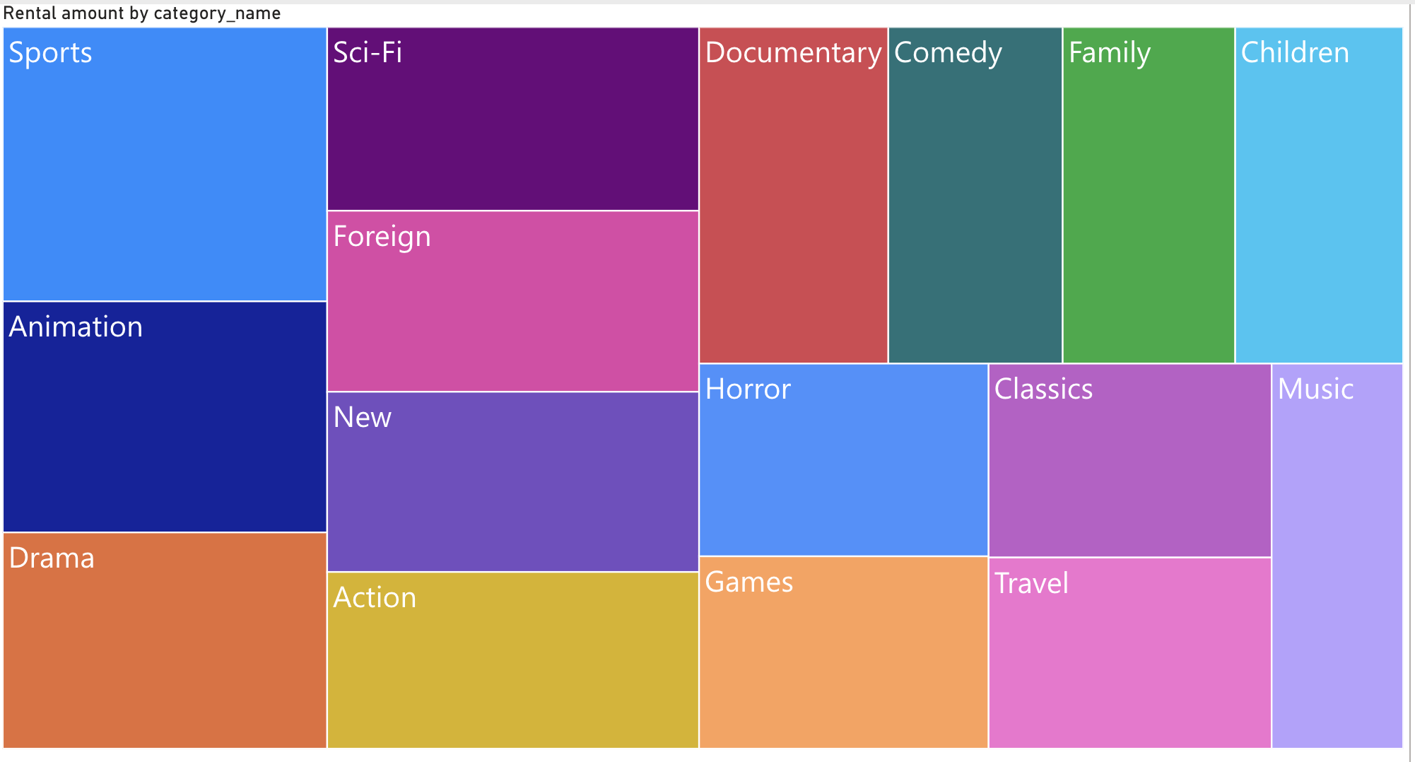
This treemap chart, "Rental Amount by Category," expresses graphically the distribution of the rental amount across various categories of films, indicating the relative significance of each category in regard to rentals. Each rectangle corresponds to a category of film. The size of each rectangle indicates the total rental amount of that particular category. The chart indicates that the Sports and Animation categories are the largest in terms of area, which thereby infers that they generate the largest rental amounts. Other large categories include Sci-Fi, Documentary, Comedy, and Family, indicating a strong interest by customers and rental activity. Smaller rectangles for categories like Music, Travel, and Classics indicate lower rental amounts. The next visualization provided the necessary insight into the top categories of films, thus highly supporting strategic decisions in inventory management, focus of marketing efforts, and improvement of customer satisfaction through fine-tuning offerings based on popular categories.

Average of Replacement cost by Category name:
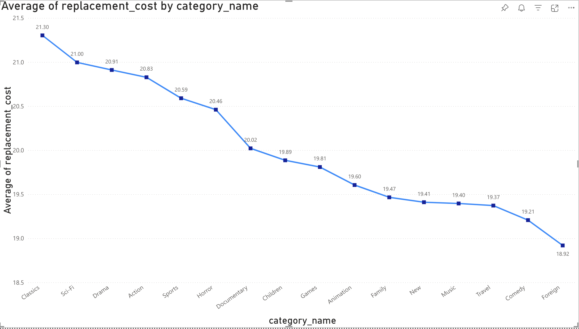
This line chart represents the average of replacement cost by category. In this graph, the horizontal axis contains the list of film categories and the vertical axis is the average of the replacement cost. The results depict that the highest average replacement cost is for Classics at $21.30, followed by Sci-Fi at$21.00 and Drama at $20.91. Other high categories include Action, Sport, and Horror, all ranging from $20.83 down to $20.46. At the low end, foreign films had an average replacement cost of $18.92, while comedies had an average cost of$19.21, and travel averaged $19.37. This plot is useful to find out which film types have a higher cost associated with the replacement of the films when budgeting or considering inventory.

6.2 Employee Dashboard
The employee dashboards consist of all those reports related to the enhancement of customer satisfaction & retention, which helps the employees monitor and analyze the customer buying patterns.

Top Customers based on Rental amount:
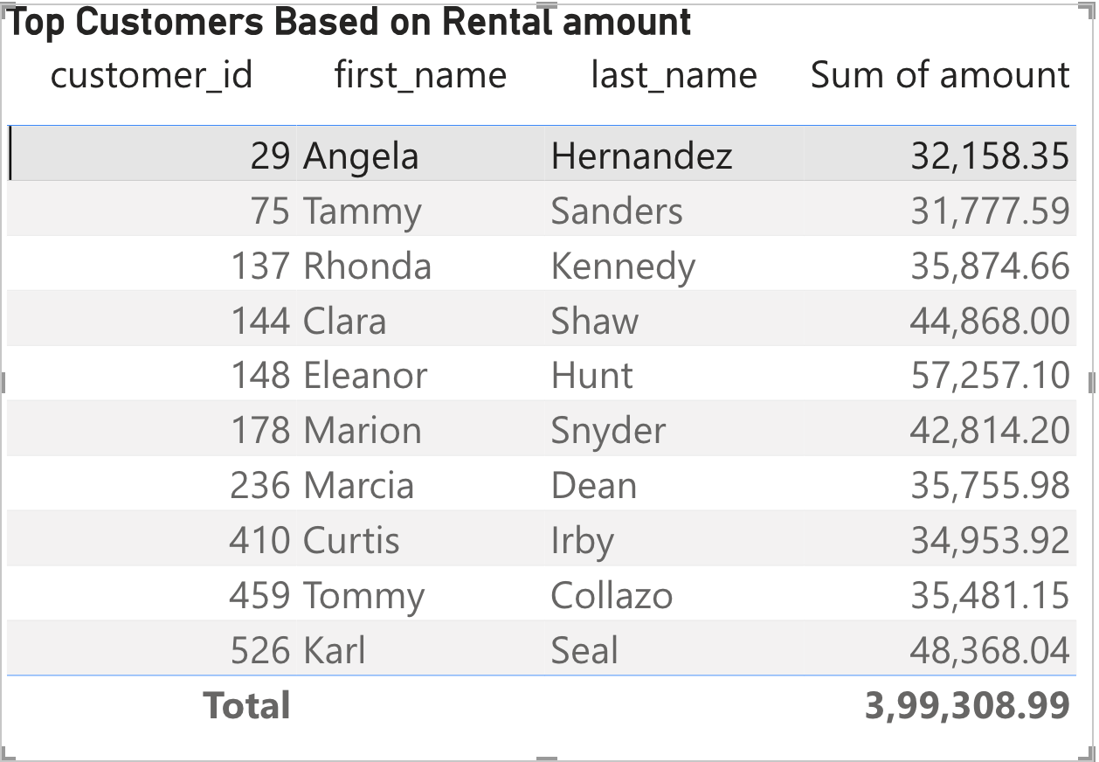
This table, "Top Customers Based on Rental Amount," gives details of the highest-spending customers by providing their customer ID, first and last names, as well as the total rental amount. The above information is useful in identifying high-value customers to fine-tune marketing strategies or high-value loyalty programs.

Top Rented Films:
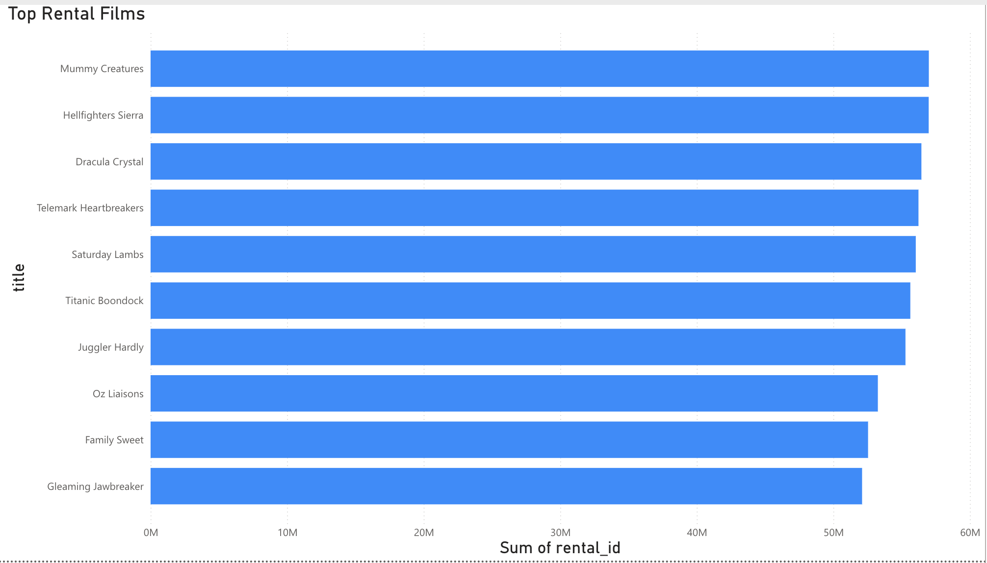
This horizontal bar chart, "Top Rental Films," identifies the top ten rented films and gives a clean overview of each film's rental performance. Each bar corresponds to one movie, while the length of each bar corresponds to the sum of rental IDs—hence, the total times each movie has been rented. The chart indicates that "Mummy Creatures" is at the top, closely followed by "Hellfighters Sierra," "Dracula Crystal," and "Telemark Heartbreakers." Other popular titles in this category include "Saturday Lambs," "Titanic Boondock," "Juggler Hardly," "Oz Liaisons," "Family Sweet," and "Gleaming Jawbreaker." This chart may be used to provide insight into which movies perform the best based on rentals and could be used to determine which titles are the most popular with customers, enable strategies to be developed for inventory and promotional decisions, and decide which types of films to stock in the future to best meet demand from the viewers.

- Appendix

  - Link for the Presentation

  - Summary of Time Team Members Worked

Name | Hours Worked
Deepika Maram | 18
Nikita Vijayrao Zatale | 18
Omkar Sai Munjuluri | 18
Supriya Mulpuru | 18

  - References
- Microsoft documentation on Azure Synapse Analytics.
- DVD Rentals Sample Dataset.
- Documentation on creating reports & dashboards in Power BI.

